Lab Activity: Implementing a Secure OpenVPN Tunnel
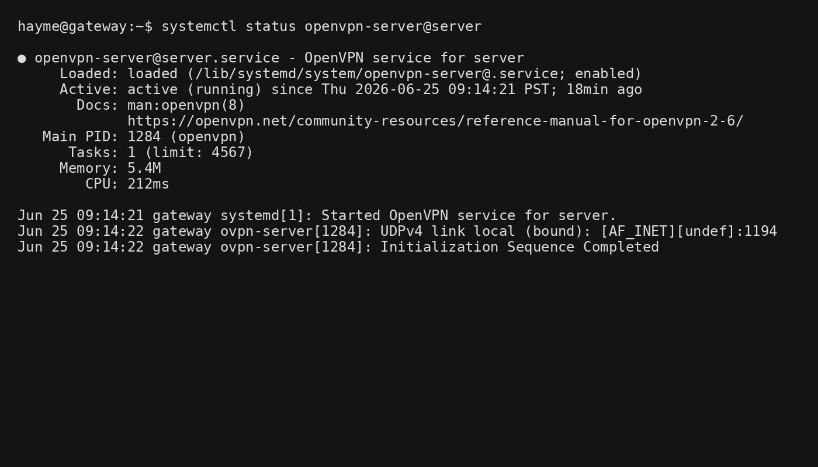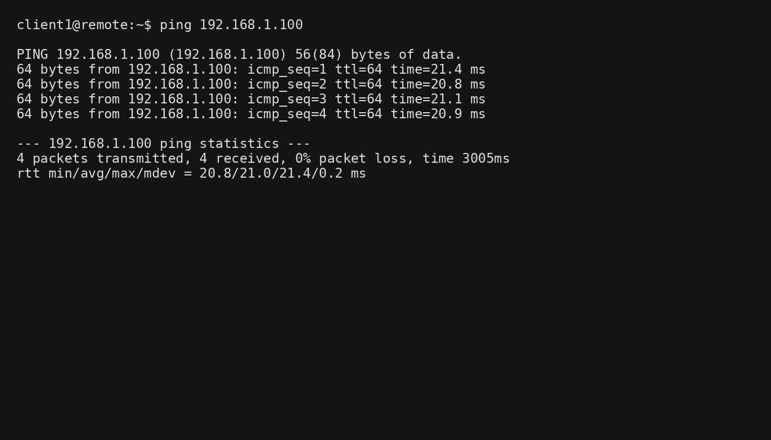
1. UDP vs. TCP: Why is UDP preferred for VPNs?
UDP is generally preferred for VPN tunnels because it has lower overhead and does not perform its own retransmission, flow control, or congestion control. Since most applications already handle reliability when needed (such as TCP-based web traffic), using TCP inside another TCP tunnel can cause a problem known as TCP-over-TCP Meltdown. This results in duplicate retransmissions, increased latency, and reduced performance. UDP avoids these issues, making VPN connections faster and more efficient.
2. PKI Security: How does a Certificate Revocation List (CRL) solve the problem when an employee leaves?
A Certificate Revocation List (CRL) contains certificates that are no longer trusted. When an employee leaves the company, the administrator revokes that employee's certificate and adds it to the CRL. Even if the former employee still has a copy of the certificate and key on their laptop, the OpenVPN server checks the CRL during authentication and rejects any revoked certificates, preventing unauthorized access.
3. Visibility: When the client pings 192.168.1.100, does the research server see the client's real IP or the VPN IP (10.8.0.6)? Why?
The research server typically sees the client's VPN IP address (e.g., 10.8.0.6) rather than the client's public Internet IP. This happens because the traffic is encapsulated and routed through the VPN tunnel. Once the packet reaches the internal network, it appears to originate from the VPN-assigned address, allowing secure communication without exposing the client's real public IP.

